**THIRD TERM E-LEARNING NOTE**

**SUBJECT:TECHNICAL DRAWING CLASS: SS2**

**THIRD TERM SCHEME OF WORK**

**WEEK 1& 2:** Revision on building details; Simple working drawing and details.

**WEEK 3 & 4:** Construction details of parts of building e.g foundation, wall openings, jamb, sill, lintel.

**WEEK 5 & 6:**  Construction details e.g roofs, doors, windows, staircases, frames, lining and architraves**,** floors,

simple reinforcement for columns, beams, piers and slabs.

**WEEK 7 & 8:** Orthographic projection of building, including sectional views and the use of different scales up tofloors only.

**WEEK 9:** Revision of construction details and orthographic projection.

**WEEK 10 & 11:** Engineering Drawing- free-hand sketching including both pictorial and orthographic sketching of

engineering components.

**WEEK 12 & 13** Revision and Examination.

**REFERENCE MATERIALS:**

Technical drawing by J.N. Green

Drafting Technology and practice by William P. Spence.

Technical drawing manual with solved past questions by E.K Ajayi.

**WEEK ONE**

**TOPIC: REVISION ON BUILDING DRAWINGS DETAILS**

**CONTENT:**

(i) Definition of terms

(ii) Details of working drawing.

Definition of terms

**Foundation:** Foundation sometimes called footing or the sub-structure is designed to support the walls and the roof and to provide a solid base on which to build a house. It helps in the evenly distribution and conduction of the entire building load on the soil in a manner that no damaging settlements take place.

**Plinth:** A plinth is normally constructed above the ground level and immediately after the foundation.

**Damp proof course(Dpc):** This is a layer of water proof material which prevents surface water from risinginto the walls.

**Floors:** This is the surface above the filling of the plinth beam on which we most of our activities.

**Walls:** This is the vertical member on which the roof structure rest.

**Openings:** Openings are made on walls to serve the purposes of ventilation, reflection of day light into theinteriors of a building and for beauty. Examples of openings include: windows, doors, arches, manholes etc.

**Meaning of working drawing**

Working drawing is a type of architectural or mechanical drawing from which construction work is actually carried out. Therefore, they must give all the graphical information necessary for constructional purposes and must be accurately drawn in orthographic projection showing the plan, elevations and essential sections. There are working drawings for mechanical components, site plan, foundation plan, floor plan and elevations. They must have detailed dimensioning, appropriate titles and the scale used.

**EVALUATION**

1. Define a working drawing.

2. Mention some of the features of a working drawing.

**Examples of working drawing**

**Building drawing**

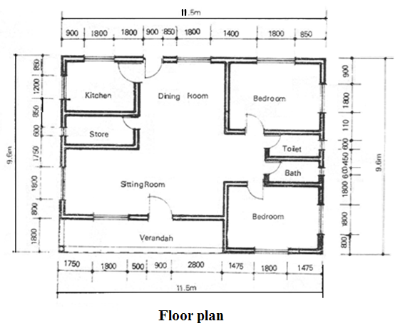

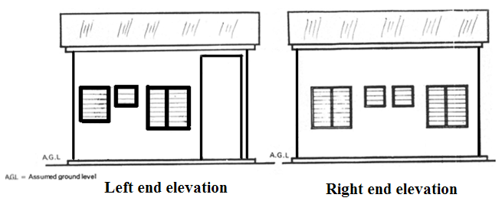

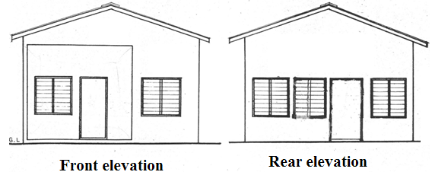

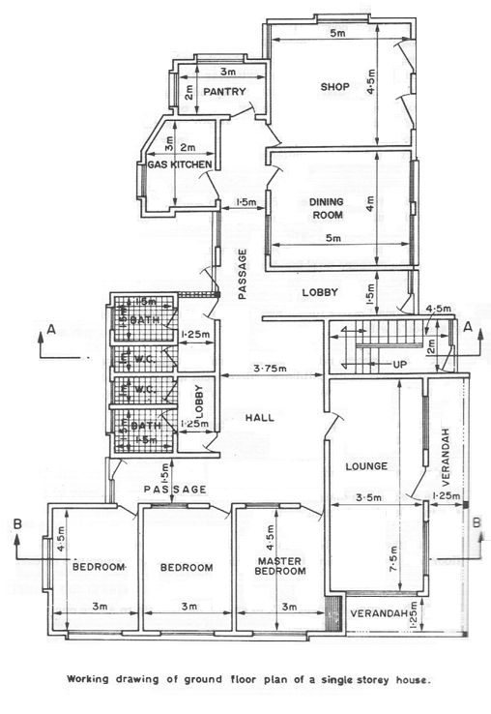

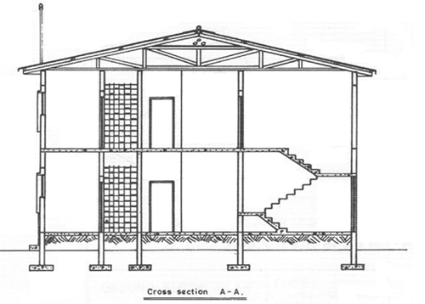

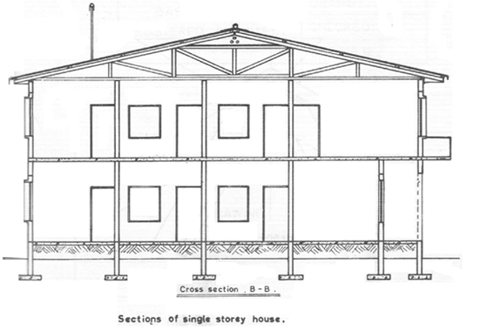

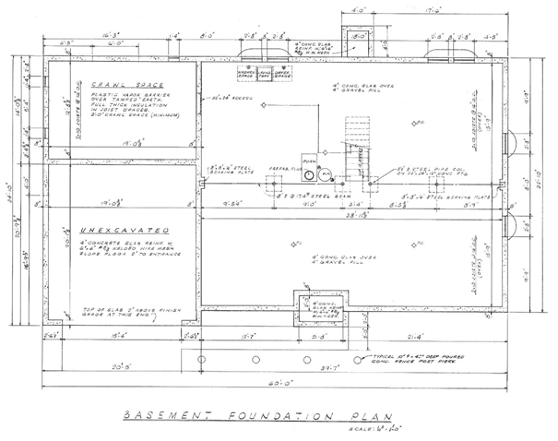

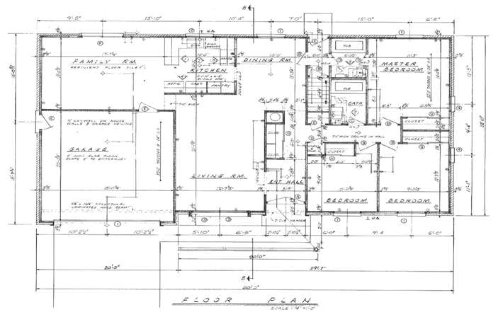

**Mechanical drawing**

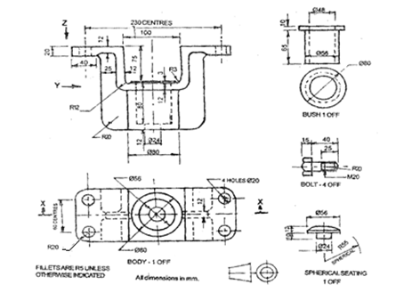

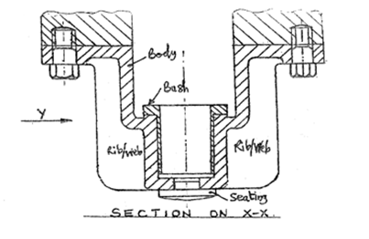

**EVALUATIONs**

1. Draw a floor plan of your dream bungalow building.

2. Sketch the front, end and rear elevations of your school building.

**READING ASSIGNMENT**

Visit [www.google.com](http://www.google.com) for types of working drawings.

Drafting technology by Spence pages 687 – 704.

**WEEKEND ASSIGNMENT**

**Objective**

1. Which of the following parts is not a member of the assembly whose two views are shown below? A. Bolt.

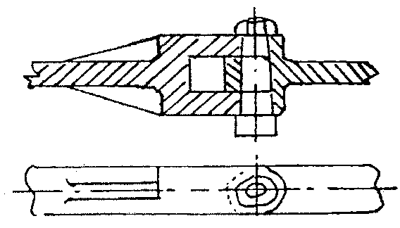

B. Web. C. Washer. D. Lever.

2. On a working drawing of a bolt. Which of the following is the correct interpretation of

‘ BOLT- 4 off ’? A. Bolt is number 4 on the bolts chart. B. 4 bolts required for the assembly. C. Bolt

should have an off-cut of 4mm. D. 4 machines are required to produce the bolt.



3. On a building floor plan, the symbol above represents A. window. B. lintel. C. door. D. column.

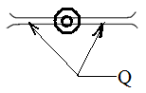

4. On a mechanical drawing shown above, Q can be identified as A. wood. B. web .C. joint. D. groove

5. In a building floor plan. the part shown below can be identified as a A. lintel B. door. C. window.

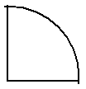

D. Arch

**Theory**

1. Mention 5 characteristics of a working drawing.

2. The figure below shows the sketch plan of a three bedroom bungalow. Study the given specifications and

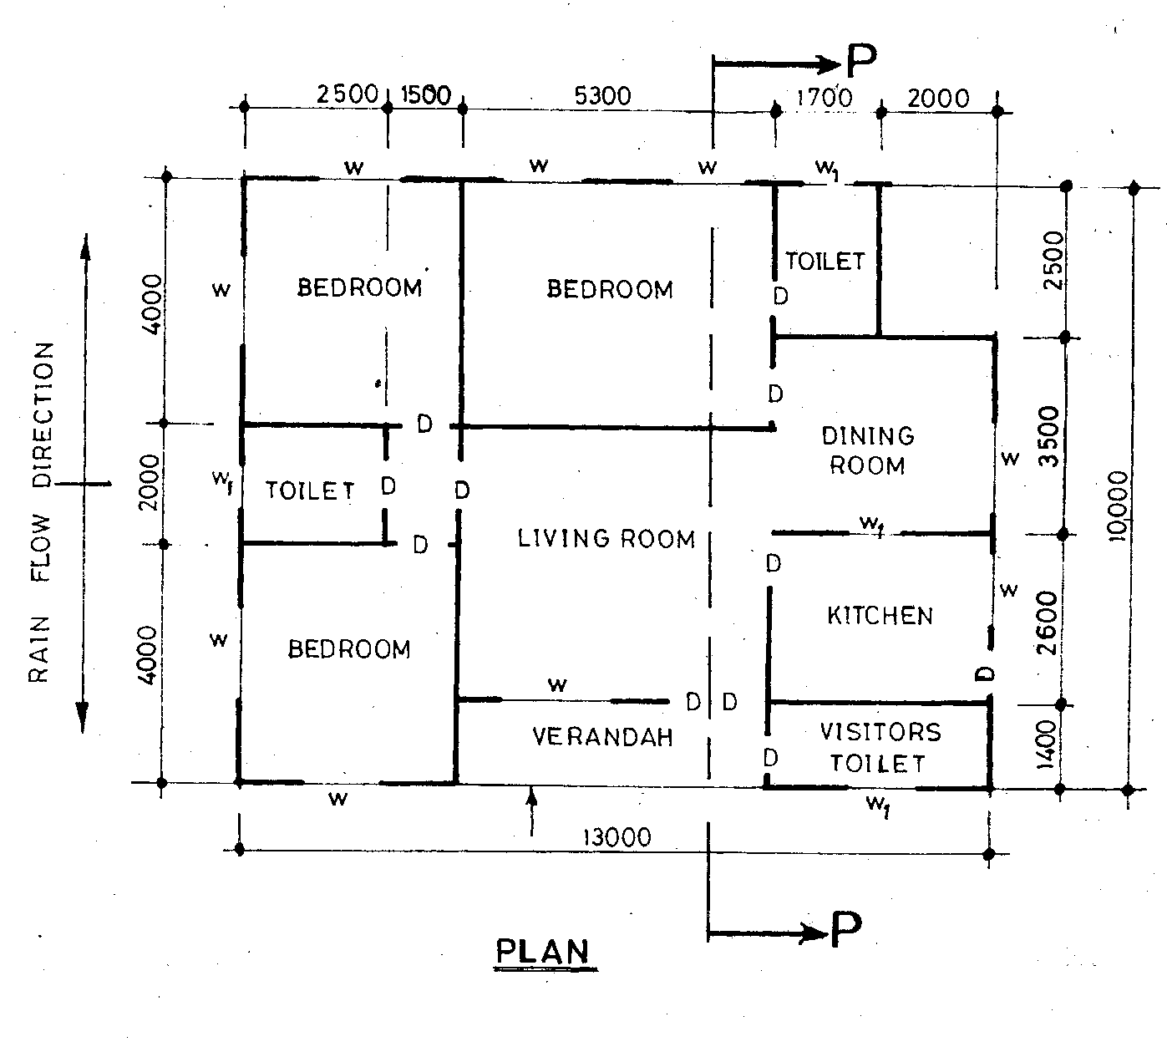

answer the following questions.

**SPECIFICTIONS**

**Foundation:** 800 X 225 strip laid 1000 below ground level.

**Wall:** All walls are 225 thick sandcrete, hollow blocks, with 13 mortar rendering on both sides.

**Floor:** 300 hardcore; 150 thick concrete slab; 25 mortar screed.

Finished floor to ceiling, 3000.

**Doors:** Main entrance – 2100 X 1800 flush wooden in 120 X 80 timber frame.

Inside - 900 X 210 X 40 flush wooden in 100 X 50 timber frame.

Kitchen (outside) – 900 X 2100 fabricated metal in 100 X 50 metal frame’

**Windows**: All glass louvred with aluminum carriers in 100 X 50 timber frames.

Toilets (W1) - 800 X 500.

Others - 1400 X 1200.

**Lintel:** 225 X 255 reinforced concrete.

**Roof**: Pitch angle 120 (gable roof) with corrugated aluminum sheets; 300 eaves projection; timber

rafter 200 X 50 at 1000 centres; purlins 75 X 50 at 900 centres; ceiling joist 50 X 50 at 1200

centres.

***Note*:** (*Assume suitable dimensions where necessary*)

Draw the:

(a) floor plan of the building to a scale of 1 : 100;

(b) front elevation of the building to a scale of 1 : 100;

(c) sectional elevation P – P of the building to a scale of 1 : 50.

**WEEK THREE**

Topic: Building foundation.

Content:

(i) Meaning of building foundation.

(ii) Types of building foundation.

The meaning of building foundation

Foundation sometimes called footing or the sub-structure is designed to support the walls and the roof and to provide a solid base on which to build a house. The type of foundation chosen will depend on two distinct variables which include: the total building load ie weight of the house and the type and quanlity of the sub-soil. In addition, different weather conditions and soil types may reduce the effectiveness of foundation. Frost heave for instance is common in sandy soil where water in the ground freezes and pushes upwards as it expands into ice. Also, drought which causes shrinking of the land is most common in clay soil. Both conditions can seriously affect the foundations; causing disturbance and making them to crack. These problems could easily be avoided by digging deep into the soil. Usually, at least two-third of a metre is suitable.

**EVALUATION**

1. Explain what you understand by building foundation.

2. Discuss the factors to be considered in the choice of foundation made for any building.

Types of building foundations

1. **Strip foundation:** Strip foundations are created by excavating a trench deep enough until clay is reached. The bottom of the trench is covered with at least 150mm thick concrete. Note that if the site is sloppy, one or more steps may be built into the concrete with forms that guides the depth. Once the footings are complete, cavity walls are built up to finished ground level using bricks or blocks. The trench and cavity are back filled up to finished ground level.

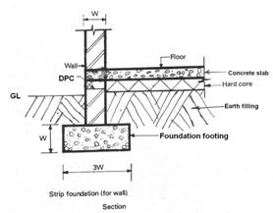

2. **Raft foundation:** This type of foundation covers an area at least the same size as the base of the building. They are used on soft compressible sub-soil such as soft clay or peat. However, it is important that they are well reinforced to resist the effect of ground movement.

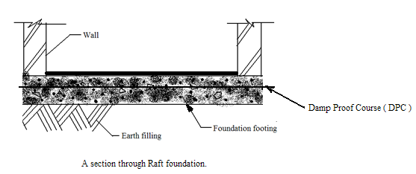

3. **Pile foundation:** Pile foundation are used to support buildings in subsoil conditions such as shrinkable clays, infill or waste tips, slopes and sites with a high water table in a poorly drained region. A basic pile foundation is a series of stilts or columns which rest on a solid load bearing layer of the soil up to 4m or more below the surface depending on the nature of the soil. Piles are driven into the soil by pile drivers.

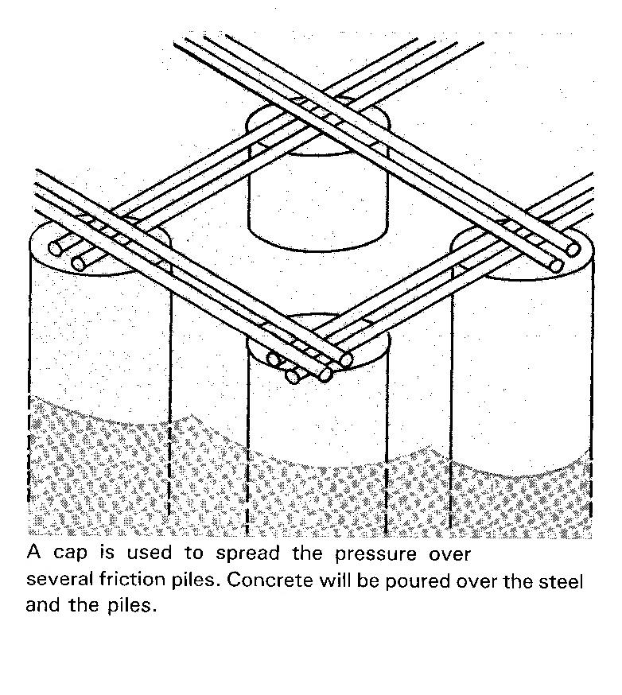

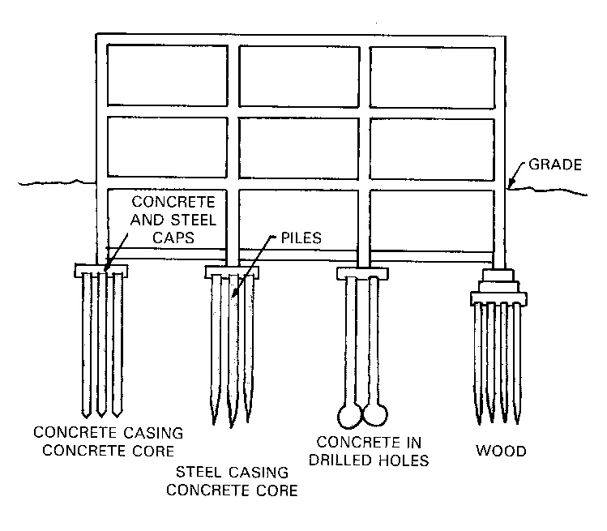

4. **Pier foundation:** Piers transmit the weight of the structure to a bearing surface. They are larger in

diameter than most piles and are of different shapes. They are used to support buildings or utility projects

such as overhead bridges built over large volume of water.

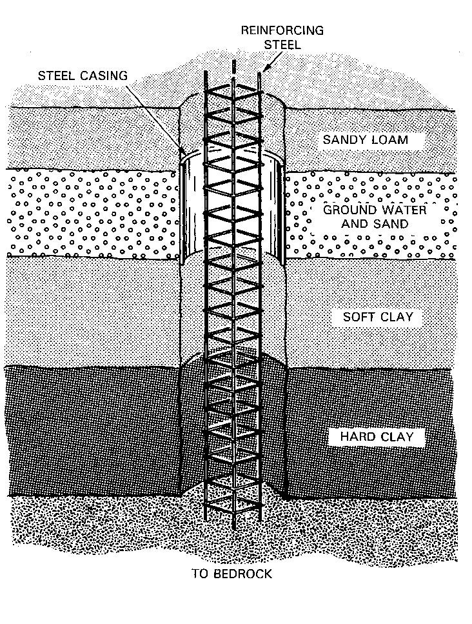

5. **Pad foundation:** This type of foundation is mostly used when columns are needed to raise the structure of

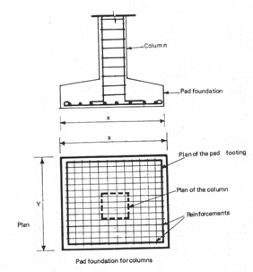

the building. They are reinforced with iron mesh and rods as seen in the figure below.

**GENERAL EVALUATIONS**

1. Mention 4 types of foundation.

2. Advice as a civil engineer the type of foundation suitable in a swampy land.

3. Explain the importance of caps used in pile foundation.

**READING ASSIGNMENT**

Visit [www.google.com](http://www.google.com) for building foundations.

Exploring construction by Richard M. Henak pages 169-173.

**WEEKEND ASSIGNMENT**

**Objective**

1. What type of foundation is suitable for building bridges? A. Raft. B. Pad. C. Pile. D. Wide strip.

*The figure below shows a section through a foundation. Use it to answer Questions* 2 *and* 3.

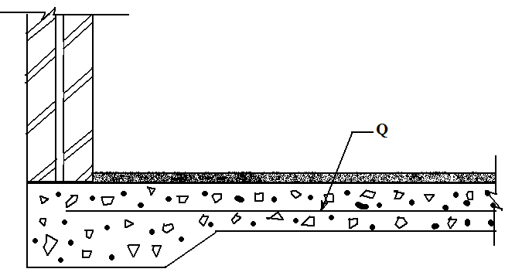

2. What type of foundation is shown above? A. Stepped. B. Raft. C. Pad. D. Strip.

3. The part labelled Q is called A. reinforcement. B. ground level. C. damp proof course. D. blinding.

4. Which of the following is the **correct** sectional representation of a foundation?

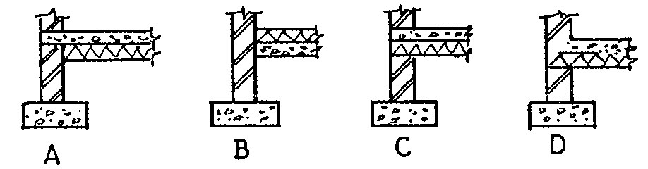

5. What type of foundation would you suggest as best for a 3-bedroom bungalow which is to be built on a solid

stony soil? A. Raft. B. Pile. C. Strip. D. Pad.

**Theory**

1. Draw a fully labelled section through a strip foundation.

2. Differentiate between the following: GL, FL and DPC in a foundation.

**WEEK FOUR**

**TOPIC:WALL OPENINGS, JAMB, SILL AND LINTEL**

**CONTENT**

(i) Meaning of wall openings.

(ii) Features of wall opening.

Meaning of wall openings

Wall openings: Wall openings are openings made on walls to serve the purposes of acessventilation, reflection of day light into the interiors of a building and for beauty. Examples of openings made in walls include: windows, doors, arches, manholes etc.

**EVALUATION**

1. What are wall openings?

2. Mention 4 types of wall openings

Features of wall openings

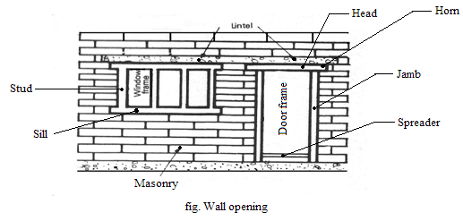

Jamb: This is the vertical side of a door frame.

Sill: The component which is placed across the bottom of a window.

Lintel: A **horizontal component** placed above a masonry opening e.g the door to support the load due to the

weight of the wall above it is called a lintel.

**GENERAL EVALUATION**

1. Draw a labelled wall opening showing a window and a door.

2. Mention 4 features of a door opening.

**READING ASSIGNMENT**

Visit [www.google.com](http://www.google.com) for types of wall opening.

**WEEKEND ASSIGNMENT**

**Objective**

The figure below shows a section through the wall of a building.*Use it to answer questions* 1 to 3.

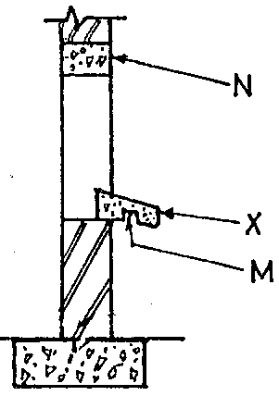

1. The part labelled X is the A. jamb. B. throating. C. sill. D. skirt.

2. The part labelled N is called A. throating. B. sill. C. jamb. D. lintel.

3. The part labelled M is the A. skirt. B. throating. C. DPC D. floor level.

4. Which of the following can be found in a door opening? A. Sill. B. Jamb. C. Eaves D. Tread.

5. A function of an internal wall is to A. carry loads. B. divide the space. C. enhance wall stability.

D. reinforce the foundation.

**Theory**

1. What are wall openings?

2. Draw a labelled wall opening showing a window and a door.

**WEEK FIVE**

**TOPIC: CONSTRUCTIONAL DETAILS OF PARTS OF BUILDING E.G ROOFS, DOORS AND WINDOWS. STAIRCASES**

**CONTENT:**

(i) Detailed structure of a roof.

(ii) Doors.

(iii)Windows

(iv) Stair cases.

**A ROOF**

**Detailed structure of a roof**

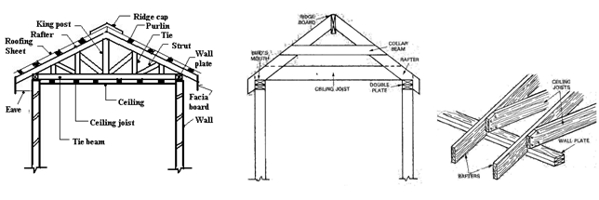

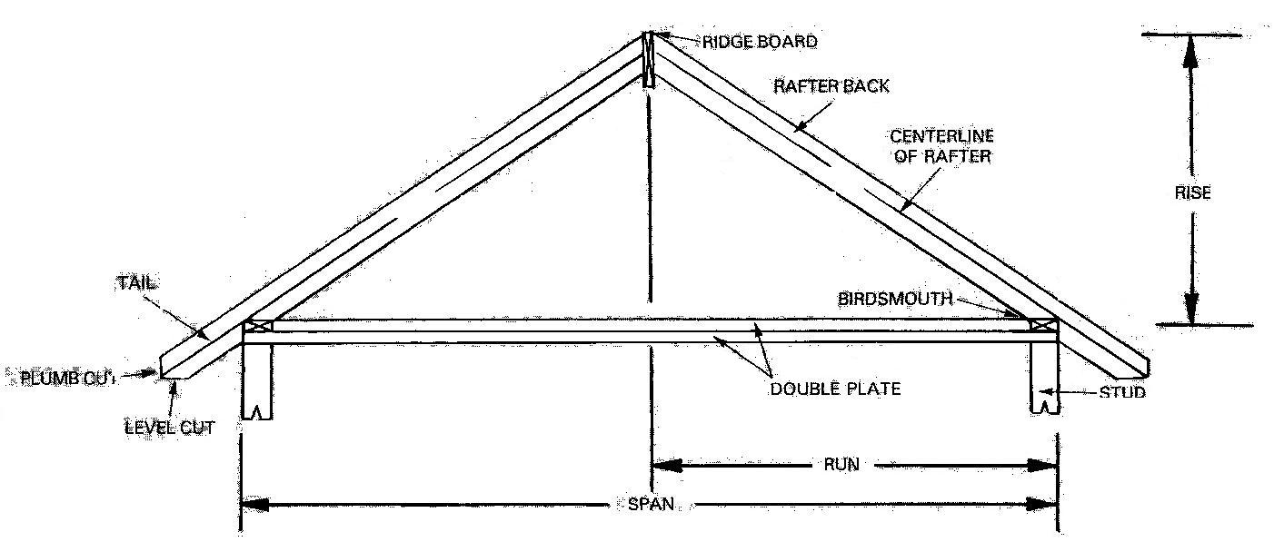

**EVALUATIONs**

1. Draw a detailed structure of a roof.

2. Analyse the location and the roof members that make up the Bird’s mouth.

3. Derive a formula for calculating the pitch angle of a roof.

**DOORS**

There are different types of doors used in buildings and these include: Panel door, Ledge and batten door, Ledge, batten and braced door and Flush door.

***Panel Door:*** The diagram below show examples of panel door. Each type is differentiated from the rest by the number of panel it has. Therefore (a), (b), (c), (d) and (e) are respectively 3-panelled, 4-panelled, 5-panelled, 8-panelled and 1-panelled door respectively.

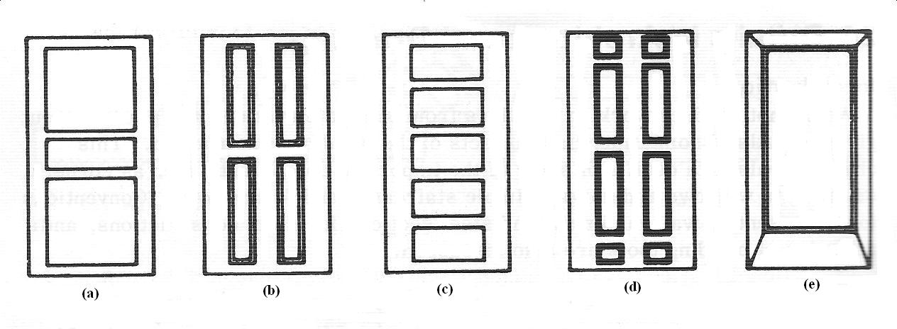

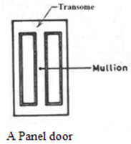

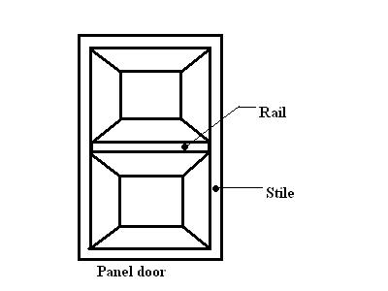

Construction of panel doors

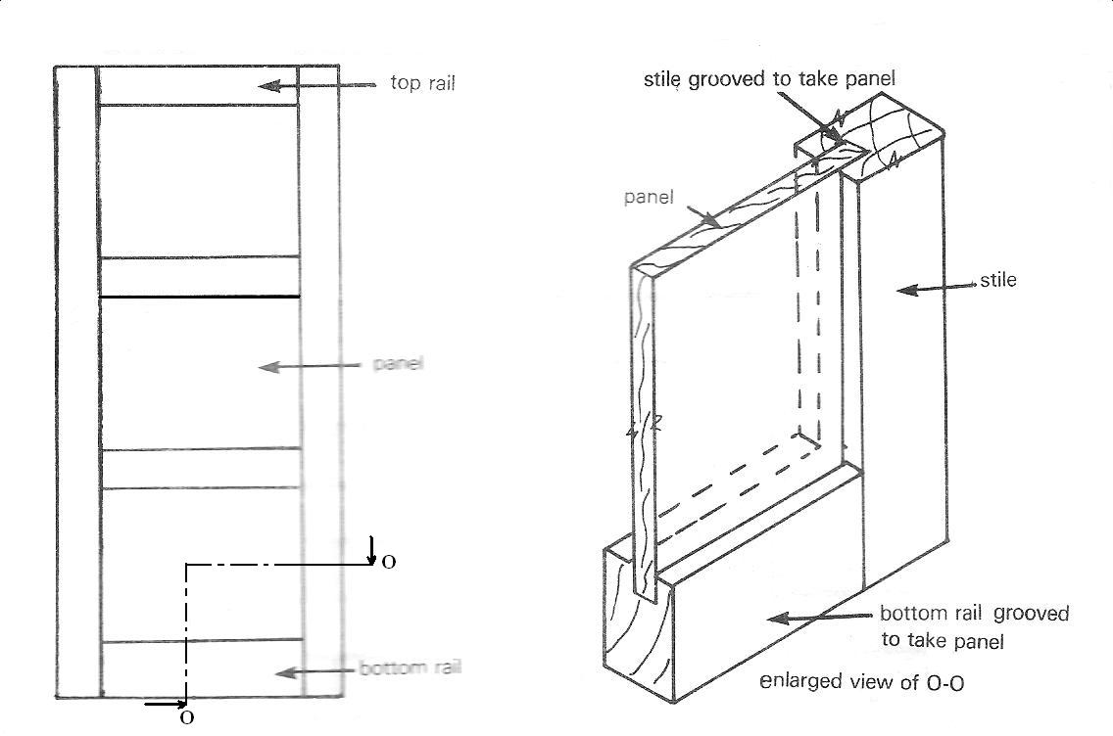

***Ledge and Batten door:*** This consists of a number of vertical battens which are nailed to horizontal rails (ledges). This type of door is commonly used for outdoor. The batten which may be squared, chamfered, grooved or tongued are screwed or bolted to the rail or ledge.

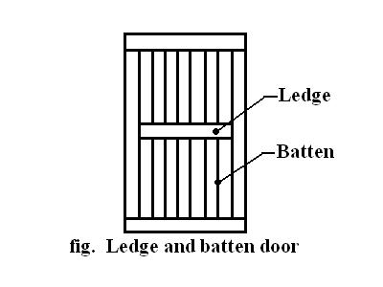

***Ledge, batten and braced door:*** This is similar to ledge and batten door but the only difference is that it has diagonal braces between ledges.

Construction of Ledge, batten and braced doors

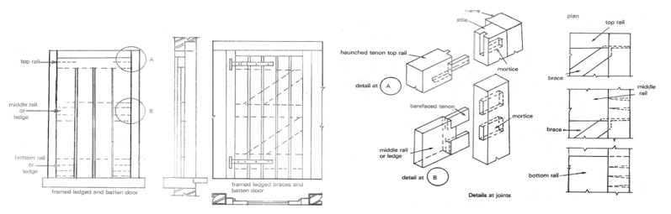

***Flush door:*** This may be solid core or hollow core and may be external or internal. See its construction below.

**Construction of flush doors**

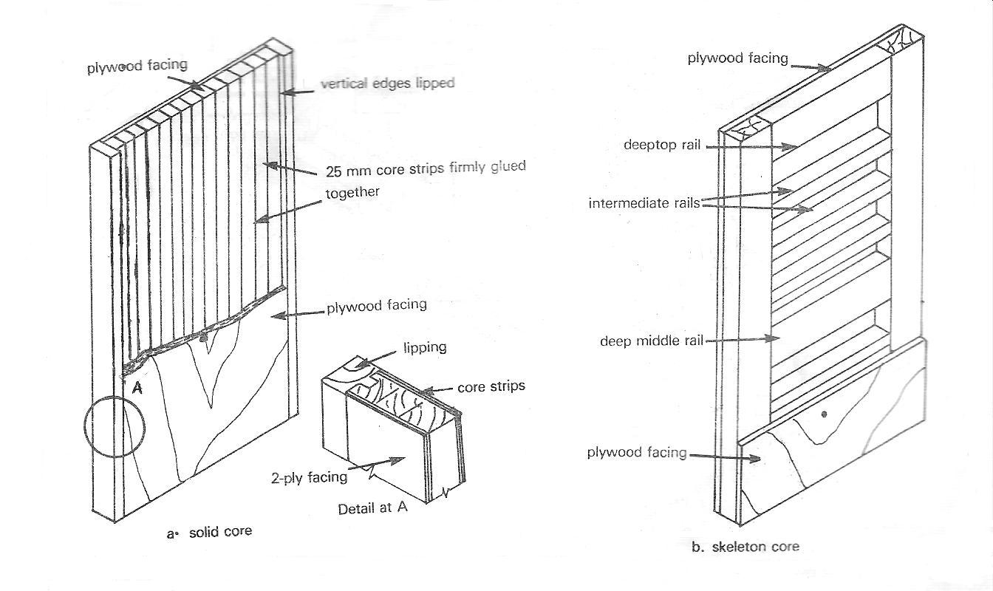

Conventional symbols of doors

**Conventional representation of doors**

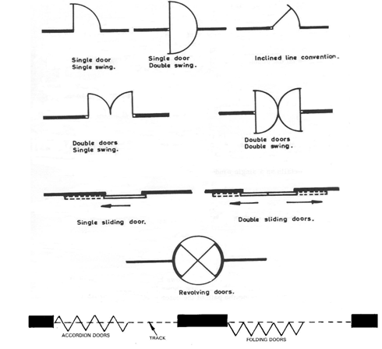

Fig. Conventional representation of doors

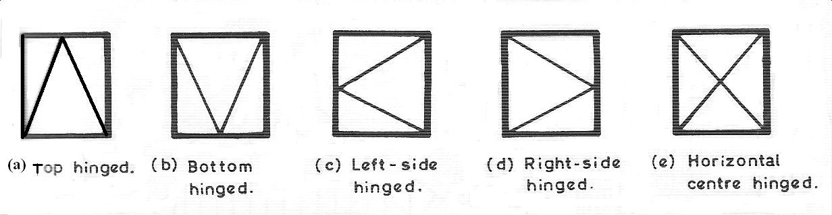

**Fig. Hinged doors**

**EVALUATION**

1. With the aid of suitable diagrams, explain 3 types of door.

2. Draw the conventional symbol of the following doors: revolving, sliding, folding and double door single

swing.

**WINDOWS**

**Windows**: The type of wall opening made on a building for the purpose of ventilation and reflection of sun light in to the room is called a window. See figures below for types of windows and their features.

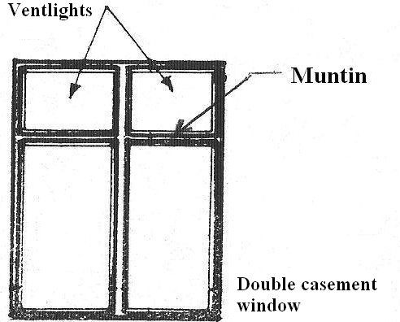

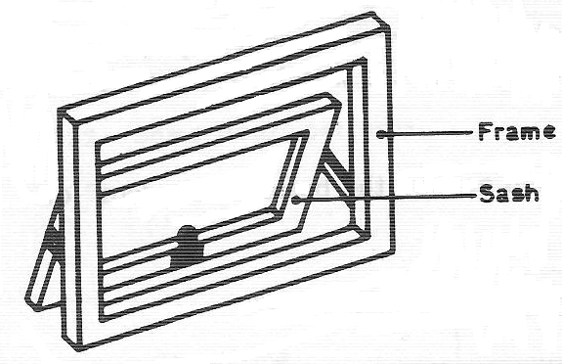

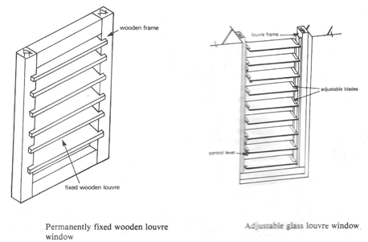

Section through doors and windows

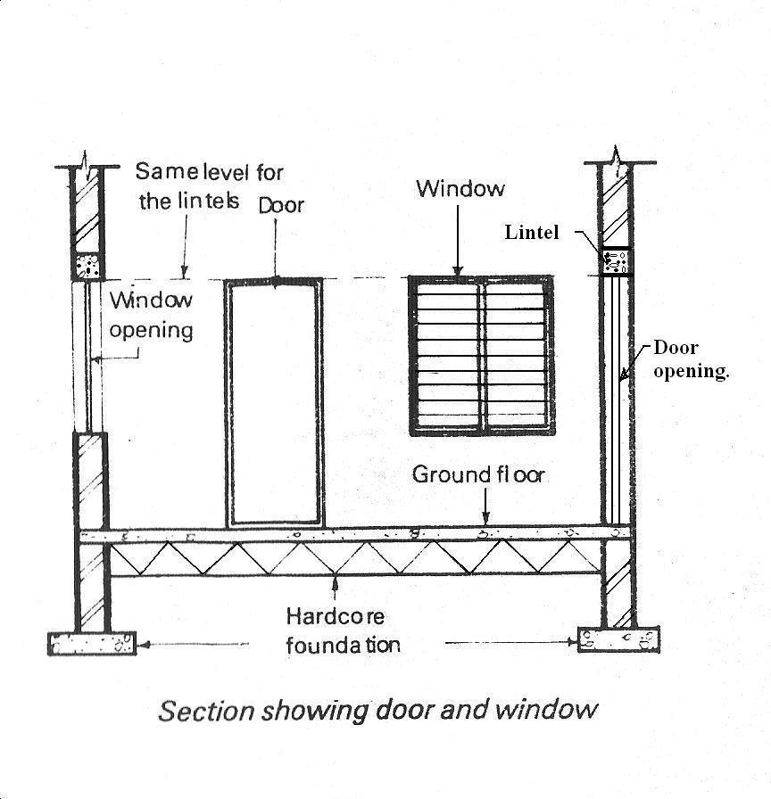

The shape or form of the section through doors and windows depend on their type and the material with which they are made.

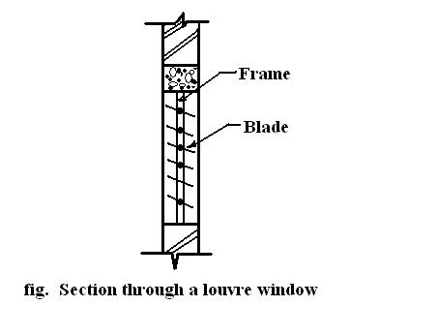

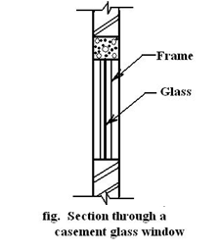

**EVALUATION**

1. Draw a diagram showing section through a door and window.

2. State two types of windows.

**Stairs and its features:**

Stairs consist mainly of horizontal parts on which the feet rest and a vertical component which must be overcome in order to ascend to the next level. A stair case should not be too steep neither should it have too gentle a slope. A slope of about 300 to 450 is desirable.

**Features of a staircase**

(i) ***Tread:*** This is a horizontal component of a staircase on which the feet rest while ascending or descending.

*(ii)* ***Riser:*** This is the vertical component of a staircase. It is however the height that need to be overcome in

order to get to the next level.

(iii) ***Head room:*** This is the height allowed to ensure that the head of the person ascending or descending the

stairs is not knocked against the roof of the stairs.

(iv) ***Landing:*** This is the little floor created at the end of each flight for resting before proceeding on the next

flight.

(v) ***Stringer or waist:*** This is a heavy plank cut at right angles to receive the treads and risers. When the

stringer is uncut, it is referred to as a carriage or a horse. In this case, the treads and risers are fastened to it

using any suitable fastening means.

(vi) ***Flight:*** The flight of a staircase is the distance covered from the nose of the first tread to the nose of the

landing.

(vii) ***Nosing:*** This is the edge formed by the end of a riser and the beginning of a tread.

(viii)**Well**: This is an open space between two straight flights.

(ix) ***Newel posts*:** These are the two standing poles at the ends of a flight on which the hand rail and

balustrades are attached. They could either be made of wood or metal.

(x) **Carriage**: This is a stair without vertical risers and tread unlike normal stairs used by pedestals, bicycle and motor cycle riders to cross a very busy road. See figure of a carriage below.

**Types of staircase**

There are different types of staircase and this include:

(i) Straight flight.

(ii) Dog-leg or half turn or U-shape.

(iii) Quarter turn or L-shape.

(iv)Spiral.

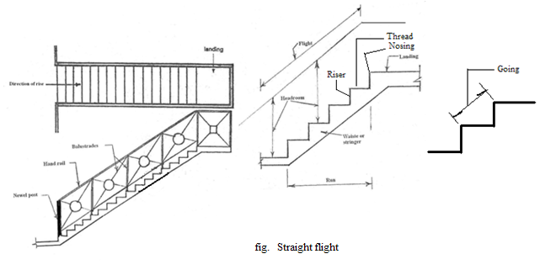

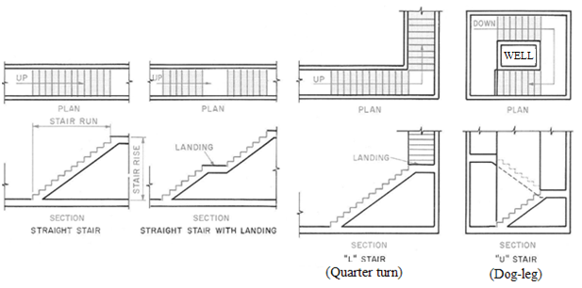

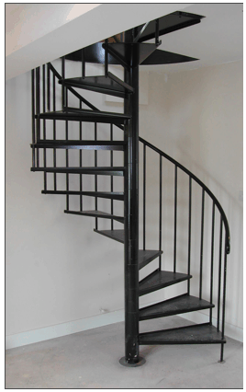

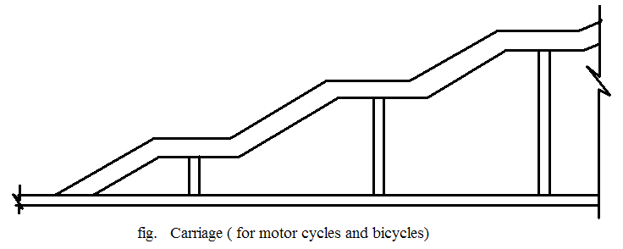

**Fig. Spiral staircase**

**GENERAL EVALUATIONS**

1. Draw a labelled diagram of a straight flight staircase.

2. State 4 types of staircase.

**READING ASSIGNMENT**

Visit [www.google.com](http://www.google.com) for types of staircase, window and door.

Drafting technology and practice by William P. Spence pages 676 – 678.

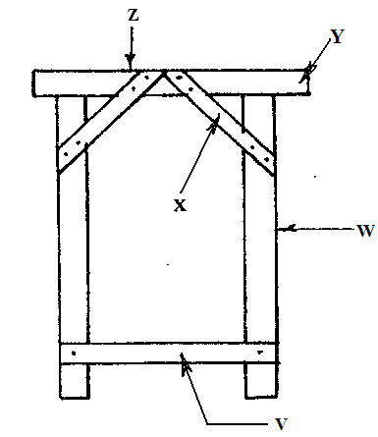

**WEEKEND ASSIGNMENT**

**Objective**

1. In the door frame shown above, the letters V, W, X, Y and Z can be identified in that order as A. horn, jamb, brace, spreader and head. B. brace, horn, spreader, head and jamb.C. spreader, jamb, brace, horn and head. D. head, spreader, horn, jamb and brace.

2.The convention for representing a bi-fold door is

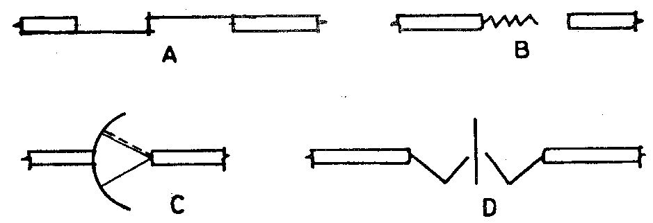

3. Which of the following is not a roof member? A. Muntin. B. Ridge. C. Purlin. D. Rafter.

4. Headroom refers to a height in the construction of a A. roof. B. window. C. stair. D. door.

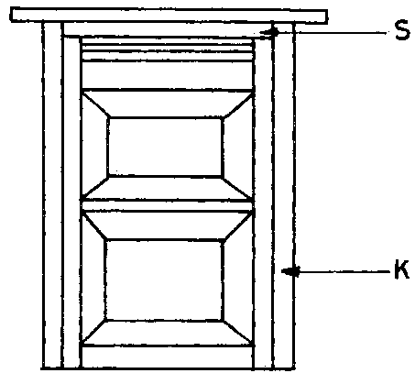

5. What type of door is shown in the figure above? A. Panel B. Ledged and braced. C. Ledged and battened.

D. Flush.

**Theory**

1. Draw a labelled diagram of a straight flight staircase.

2. Draw a detailed structure of a roof.

**WEEK SIX**

**TOPIC: CONSTRUCTIONAL DETAILS OF PARTS OF BUILDING E.G FLOORS, SIMPLE REINFORCEMENT FOR COLUMNS, BEAMS, SLABS ETC.**

**CONTENT:**

(i) Types of floor.

(ii) Reinforcement for columns, beams and slabs.

**Floors**: There are basically two types of floors and these include solid floors and suspended floors.

***Solid floors***: There are two types of solid floors and these are solid concrete and solid timber floor respectively. Solid concrete floors could either be reinforced or without reinforcement. For reinforced solid concrete floors, iron rods which are woven into mesh-like formation are used in addition to the sand, cement and granite mixture. The essence of reinforcing a concrete floor is for it to be able to withstand heavy impact without depression. These type of solid floors are used in large warehouses, large workshops with heavy machinery, multi-storey buildings, bridges etc. Solid concrete floors could either be *pre-cast or cast in-situ*(cast on site). For a solid timber floor, the timber is placed on the floor for finishing.

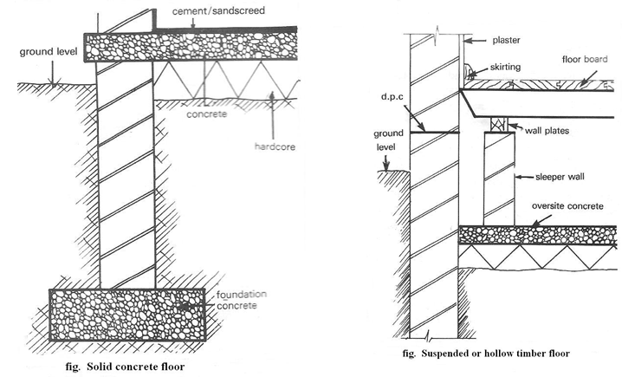

***Suspended or hollow timber floor***: Hollow timber floors have sleeper wall plate which carries the floor joist on which the boards are fixed. The diagram below shows a suspended timber floor.

**EVALUATION**

1. Mention two types of floor and explain each.

2. Draw a labelled diagram of a suspended floor.

**Columns**( pillars): These are the vertical members of a building made of reinforced concrete. These are cast

from the foundation level to support the weight of the building.

**Beams:** These are cast just the same way as columns. The only difference is that they are laid horizontally on

columns.

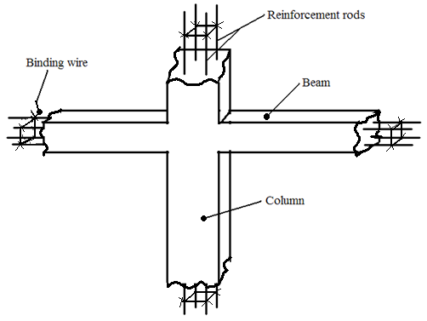

**Slabs:** These are thick flat concrete mass laid over wall openings. They are either pre-cast or cast in-situ. They are used to cover man-holes and drainage channels and for flat concrete roofs.

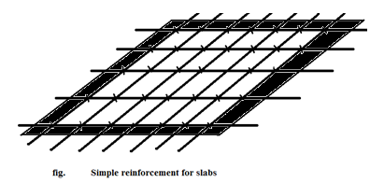

**GENERAL EVALUATIONS**

1. Distinguish between a column and a beam.

2. Distinguish between the following types of concrete. Cast in-situ and pre-cast.

**READING ASSIGNMENT**

Visit [www.google.com](http://www.google.com) for columns, beams and slabs.

**WEEKEND ASSIGNMENT**

**Objective**

1. Which of the following types of floor requires a wall plate for its construction? A. Solid concrete. B. Solid

timber. C. Suspended. D. Plastic.

2. Which of the following is a vertical member of a building? A. Beam. B. Column. C. Lintel. D. Arch

3. Slipper wall is a characteristics of A. hollow timber floor. B. roof. C. staircase. D. foundation.

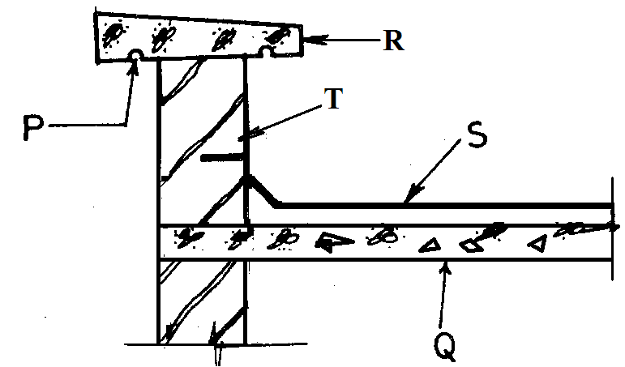

*Use the diagram above to answer Questions* 4 and 5.

4. The parts labelled P and R arerespectively A. concrete slab and bitumen felt. B. coping and parapet.

C. flashing and coping. D. slab and coping.

5. The portion labelled T is called A. coping. B. parapet. C. flashing. D. slab.

**Theory**

1. State two types of floor.

2. Distinguish between a column and a beam.

**WEEK SEVEN**

**TOPIC: ENGINEERING DRAWING IN FREEHAND SKETCHING INCLUDING BOTH PICTORIAL AND ORTHOGRAPHIC SKETCHES OFENGINEERING COMPONENTS.**

**CONTENTS:**

(i) Freehand sketching of engineering tools and components.

(ii) Examples of Engineering machines

* + ***Engineering Tools***

Below are the diagrams of some of the tools used in an engineering workshop.

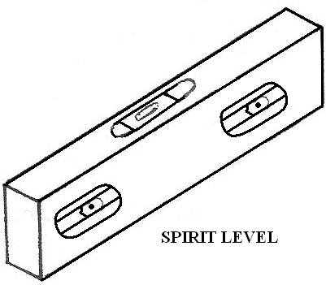

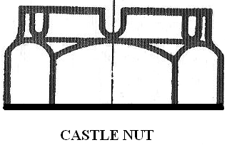

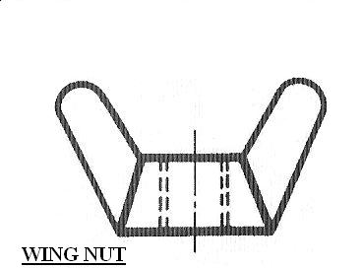

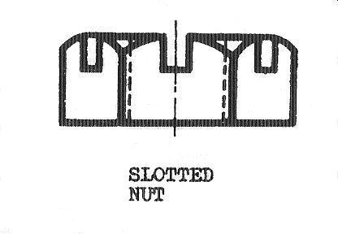

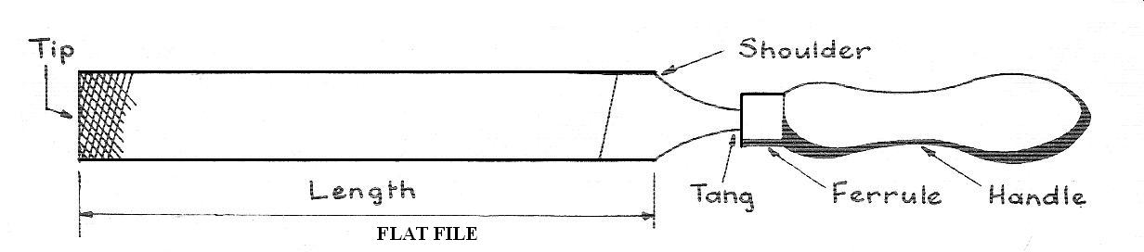

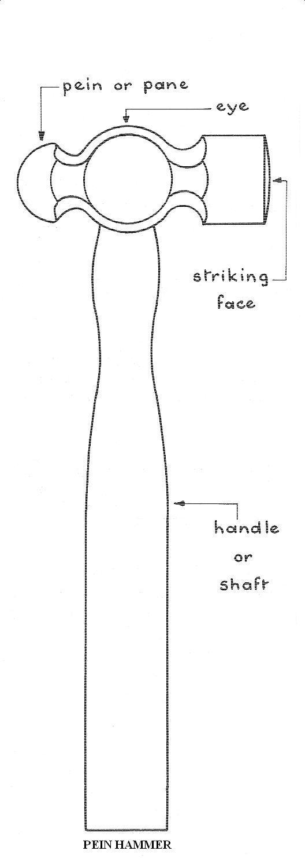

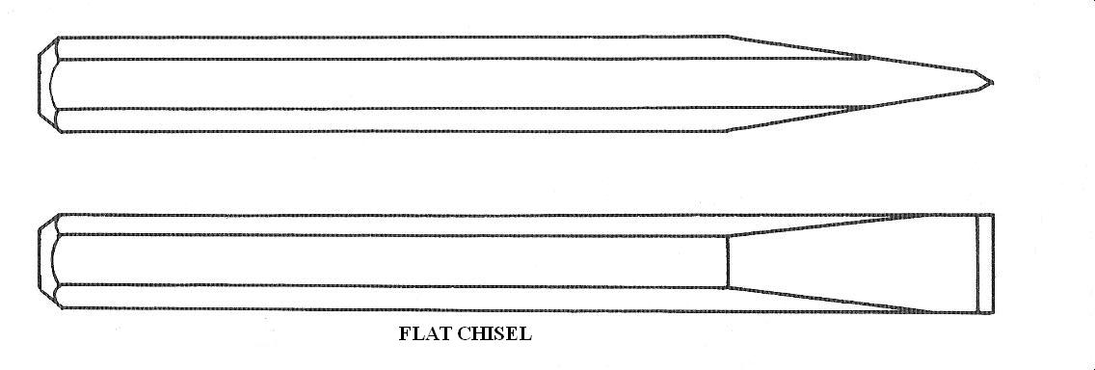

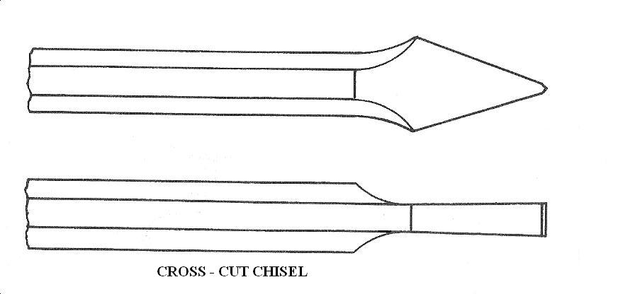

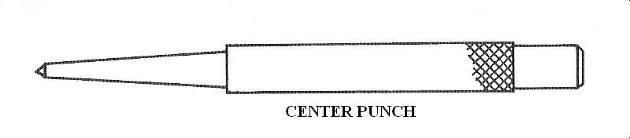



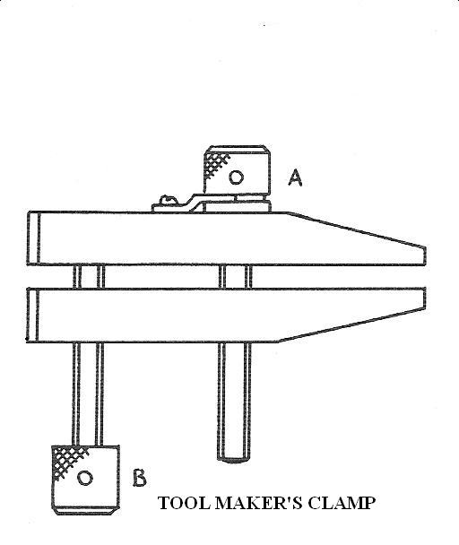

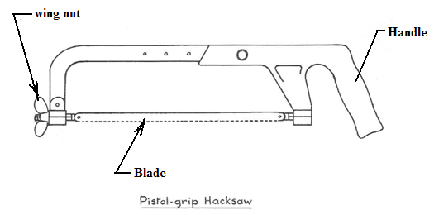

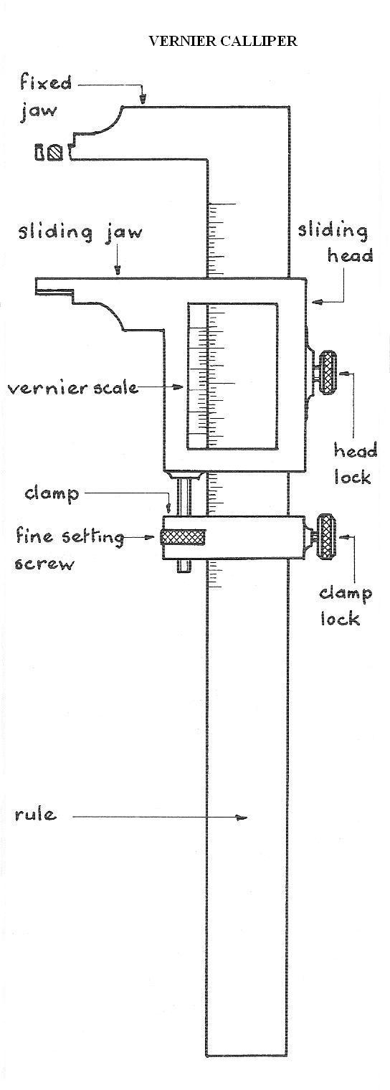

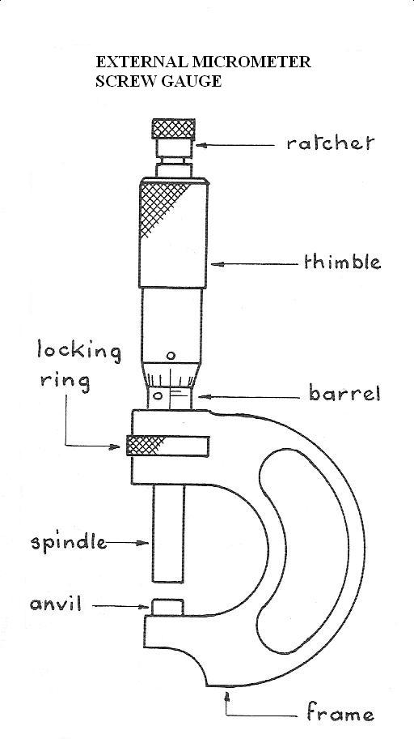

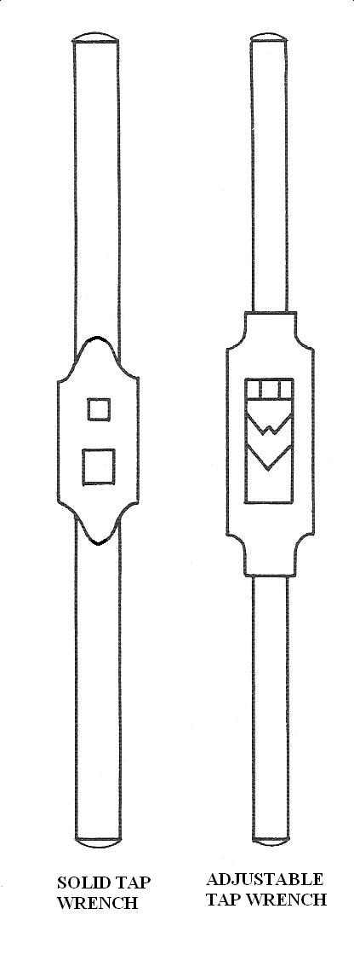

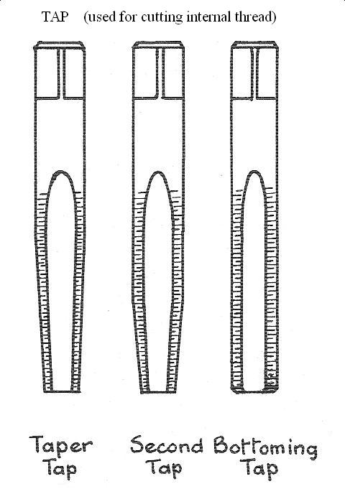

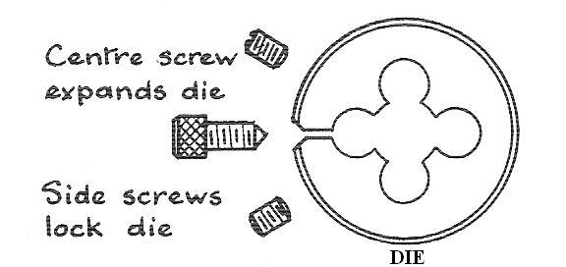

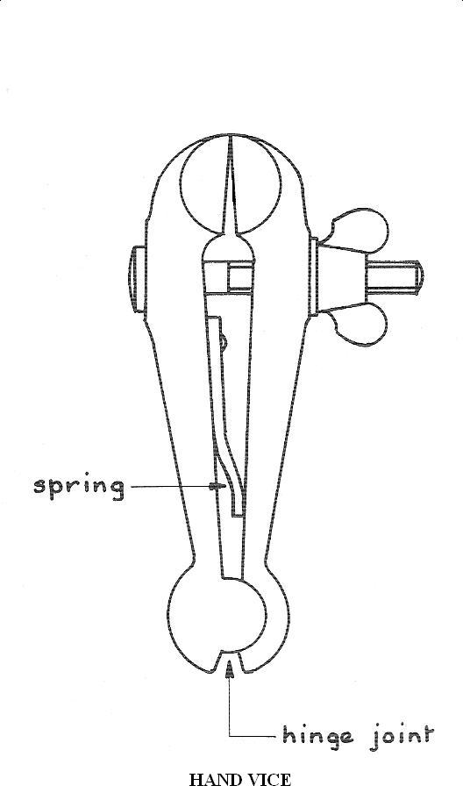

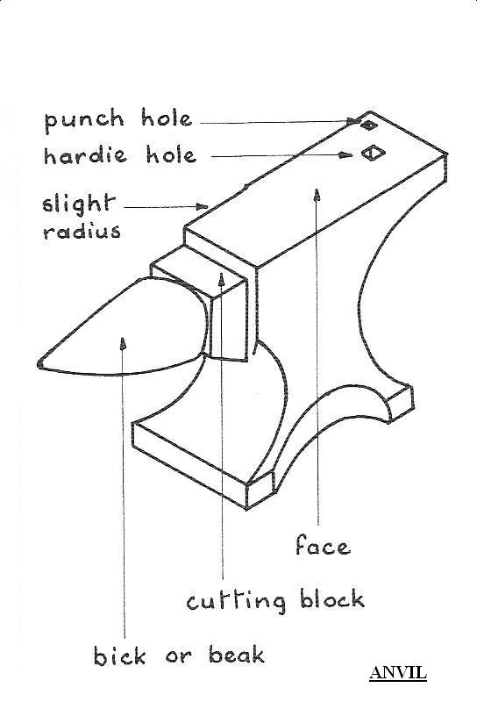

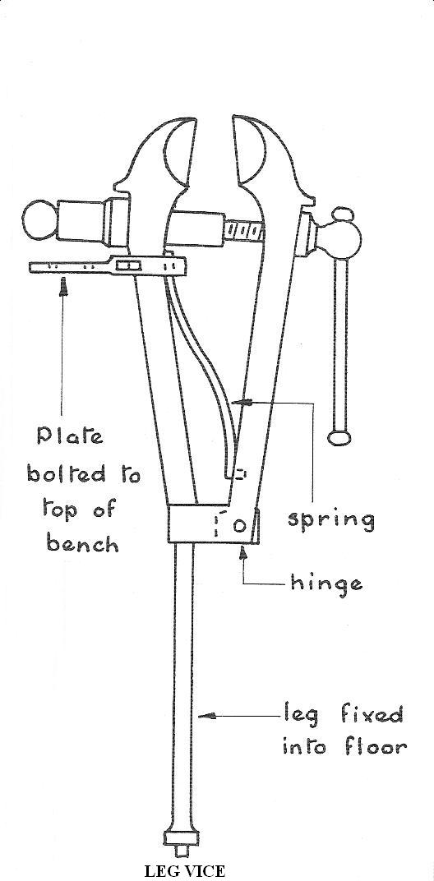

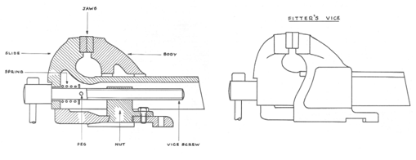

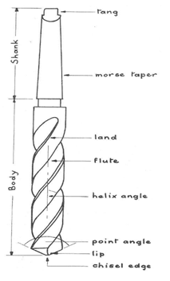

**fig Twist drill**

**EVALUATION**

1. State three types of marking-out, driving and measuring tools.

2. Sketch the following engineering tools, components or symbols using freehand sketching : Hacksaw, Sledge hammer, Pein hammer, Claw hammer, Bench vice, Chisel, Scriber, File, Twist drill, Gimlet, Gib head key , Cotter pin, Hardie, Bick iron, Slotted nut, Castle nut, Spanner, Tool maker’s clamp, Countersunk, Counter bore, Mallet, Venier calliper, Micrometer screw gauge, Split pin, Spring washer, Wing nut, Thumb screw, Grub screw, Spirit level, Hand trowel, Stud, Splined shaft, Serrated shaft, Diamond knurled surface, Straight knurled surface , Journal bearing, Split bearing, Footstep bearing, Thrust bearing, Ball bearing, Roller bearing, compression spring( schematic), Tension spring( schematic), Tri-square, a pair of pincers, a pair of pliers, gimlet, etc.

***Engineering Machines***

Below are diagrams of some machines used in engineering workshops

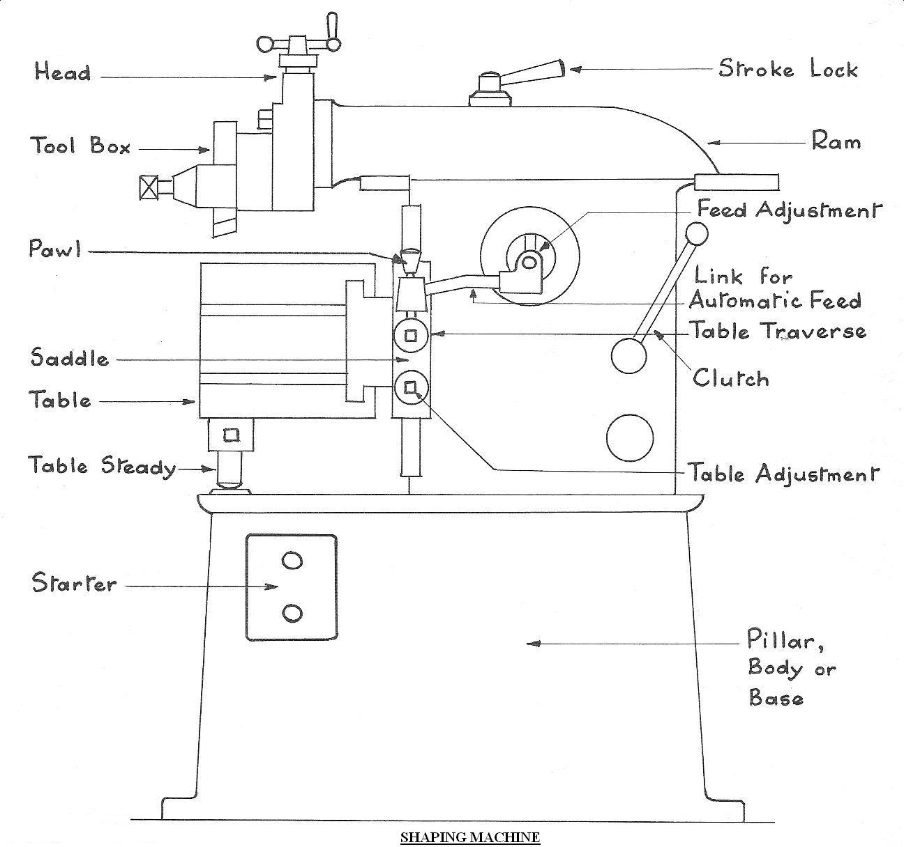

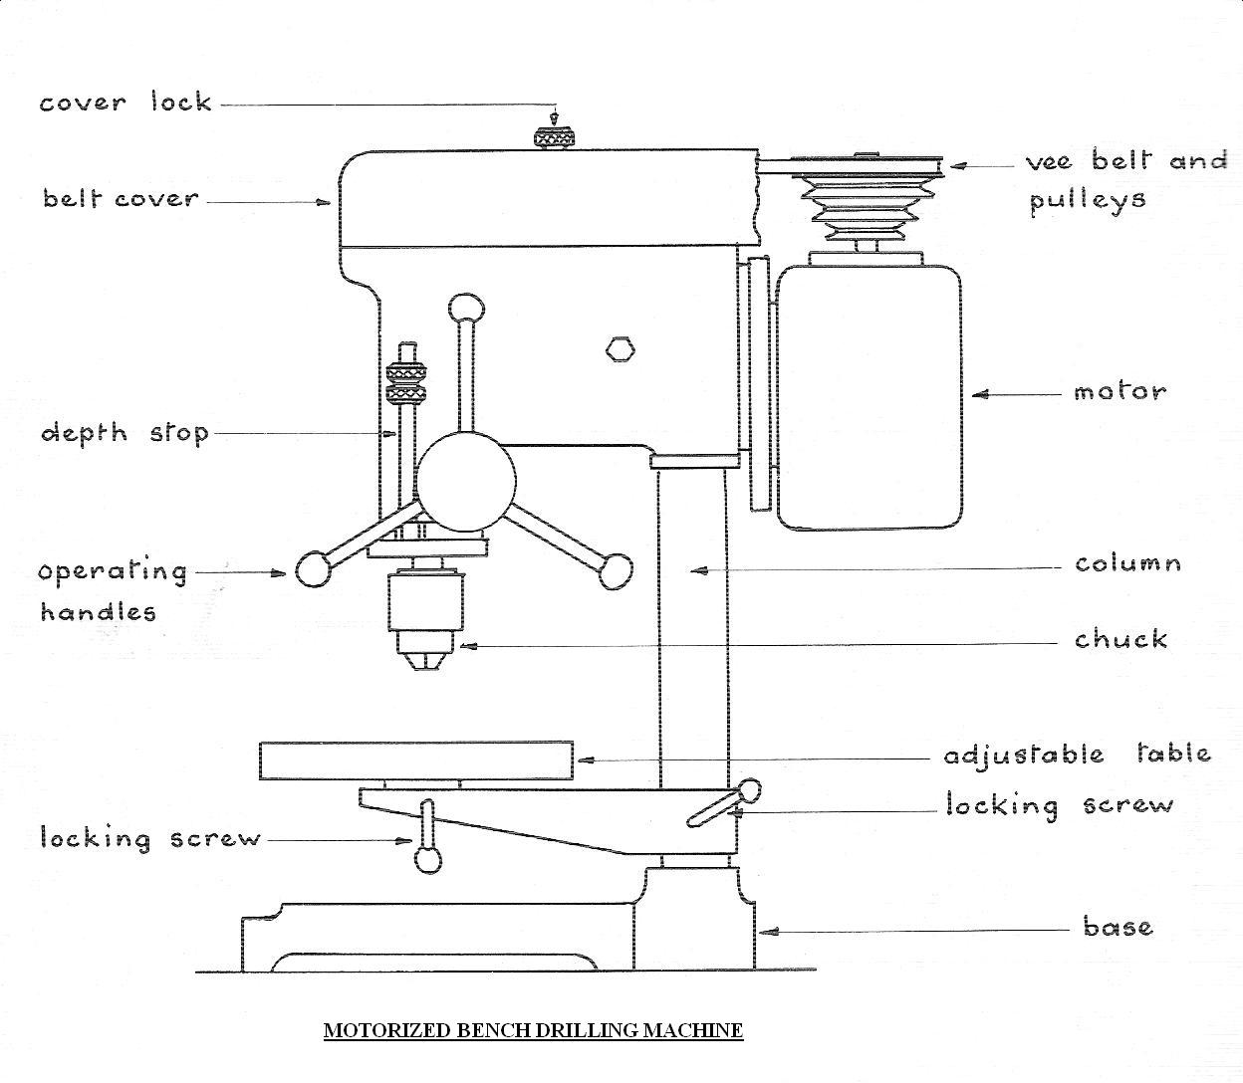

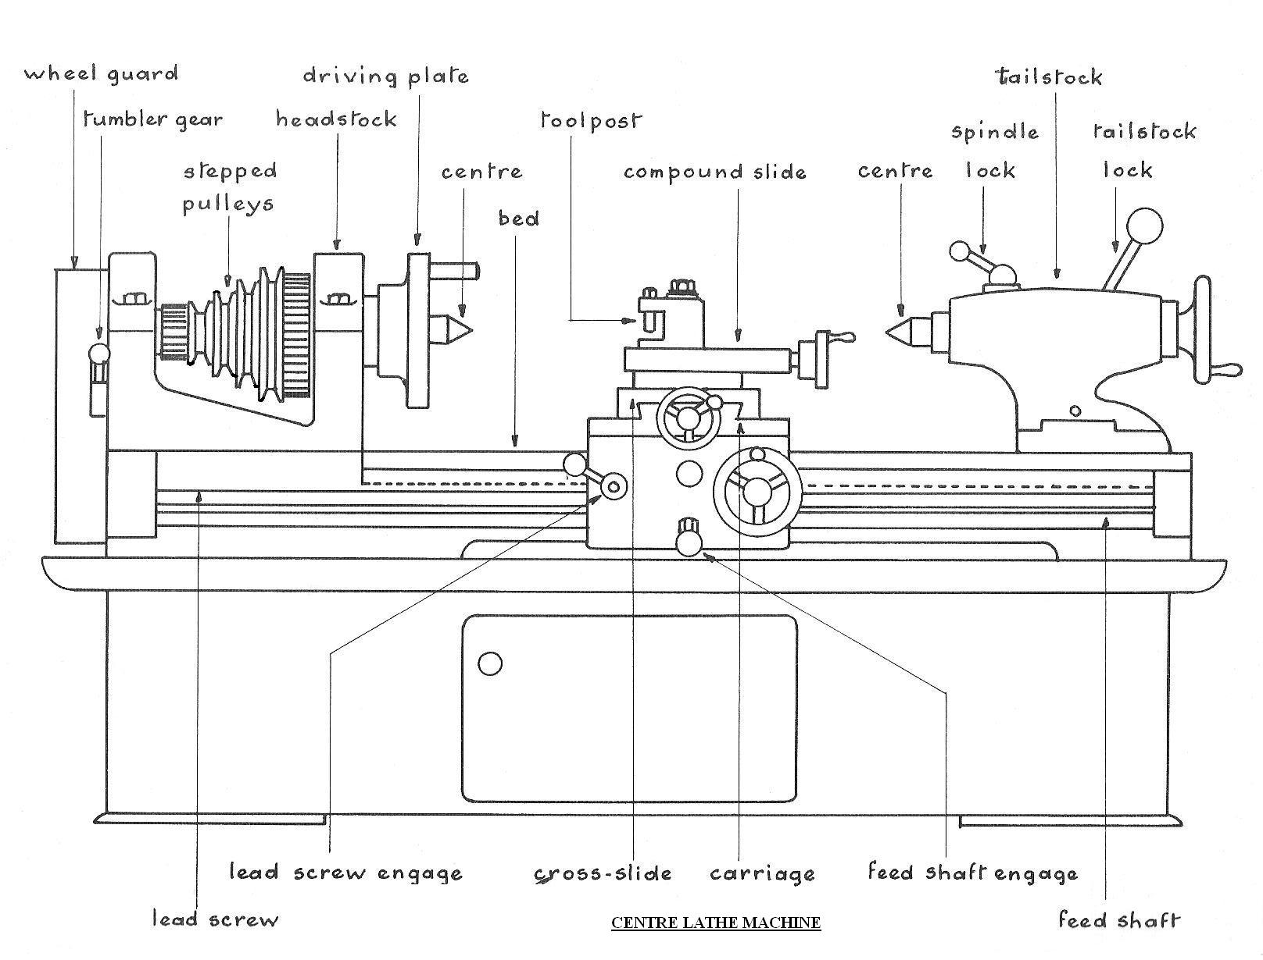

**EVALUATIONs**

1. State four types of machine used in a mechanical engineering workshop.

2. Sketch a labelled diagram of a centre lathe machine. State its uses.

**READING ASSIGNMENT**

Visit [www.google.com](http://www.google.com) for types of engineering tools and components.

**WEEKEND ASSIGNMENT**

**Objective**

1. What is the name of the engineering tool used in compacting soil shown below? A. Hammer. B. Rammer.

C. Box. D. Mallet.

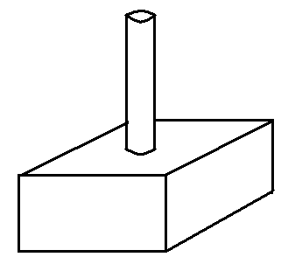

2. The following tools are suitable for removing fastened nail from a wood except a A. crow bar. B. pair of

pliers. C. chisel. D. pair of pincers.

3. The sheet metal tool shown below is a/an A. anvil. B. bick iron. C. swage block. D. hammer.

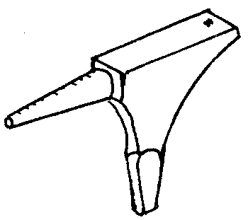

4. The figure shown below can be identified as aA. lock nut. B. thrust bearing. C. shaft. D. key.

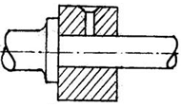

5. The engineering tool shown below can be identified as a/an A. wood. B. hammer. C. spirit level.

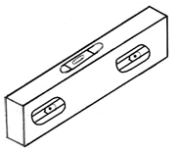

D. gimlet

**Theory**

1. Draw a well-labelled diagram of a twist drill bit.

2. Sketch the diagrams of the following tools. Bick-iron, Gimlet, Hacksaw, Chisel and a pair of pliers.